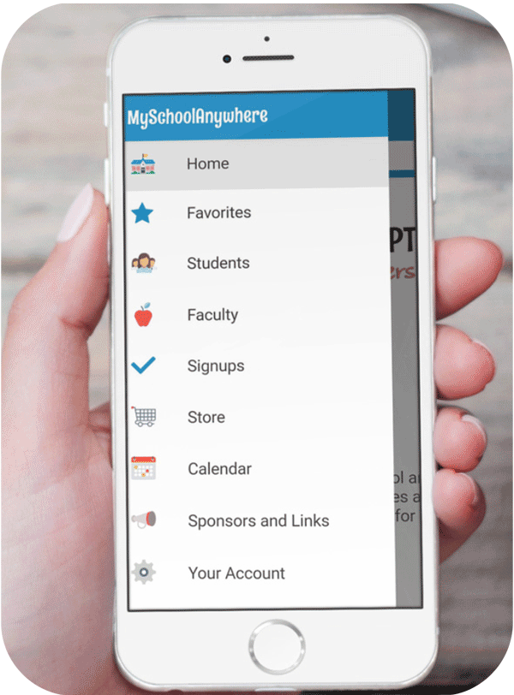
Welcome [School Name] Families!
Our [PTO/PTA/Parent Association] subscribes to the MySchoolAnywhere service for our family and faculty directories, online store, volunteer signups and email communications. It's secure, easy to use, and free to families.
If you haven't registered, please go to the site below, enter our school's code and follows the steps to register your family. You can specify what information you'd like to appear in the directory - or choose not to appear at all.
Returning Families - If you're already registered, you will receive an email asking you to update your family information and display preferences for the new school year. You do not need to register again unless you don’t receive this email.

Register at join.myschoolanywhere.com
Invitation Code: [Join Code]

Once we've had a chance to verify your family information, you'll receive an email with login credentials and instructions to access the system.
Questions? Contact our system administrator at [primaryadmin@yoursystem.com]

Install the Free app! After you receive your login information, download the app by searching for MySchoolAnywhere in the iTunes App Store or Google Play. The app allows you to access our directory, manage your family information, purchase in our store and signup for volunteer activities all from your phone!

